Prompts used and chat history
- I have cloned this Maze Chase Python/Pygame project for my lab assignment.
First, inspect the entire project and understand how the game currently works. Do not add the new features yet.
Run/check the existing code and identify any bugs or issues that prevent the current game from working correctly. Fix only those existing bugs.
Important:
- Preserve the existing game structure and functionality.
- Do not unnecessarily rewrite the project.
- Do not implement Tasks 1–4 yet.
- After making changes, verify that the game runs correctly.
- Briefly explain what you changed and why.
The required project structure is:
maze-chase/
├── main.py
├── requirements.txt
├── game/
│ ├── init.py
│ ├── game_engine.py
│ ├── maze.py
│ └── entities.py
└── README.md

2.
Implement Task 1 from the README: Multiple Enemies.
The game currently has one Enemy that uses BFS to chase the player. Add two more enemies, each starting from a different valid corner of the maze.
Requirements:
- There should be 3 enemies in total.
- Store them in a self.enemies list.
- Each enemy should independently use the existing bfs() pathfinding to chase the player.
- Update and draw all enemies using a loop.
- Make sure collision/game-over logic works with all enemies.
- Preserve the existing game functionality and structure.
Test the game after making the changes and fix any errors.
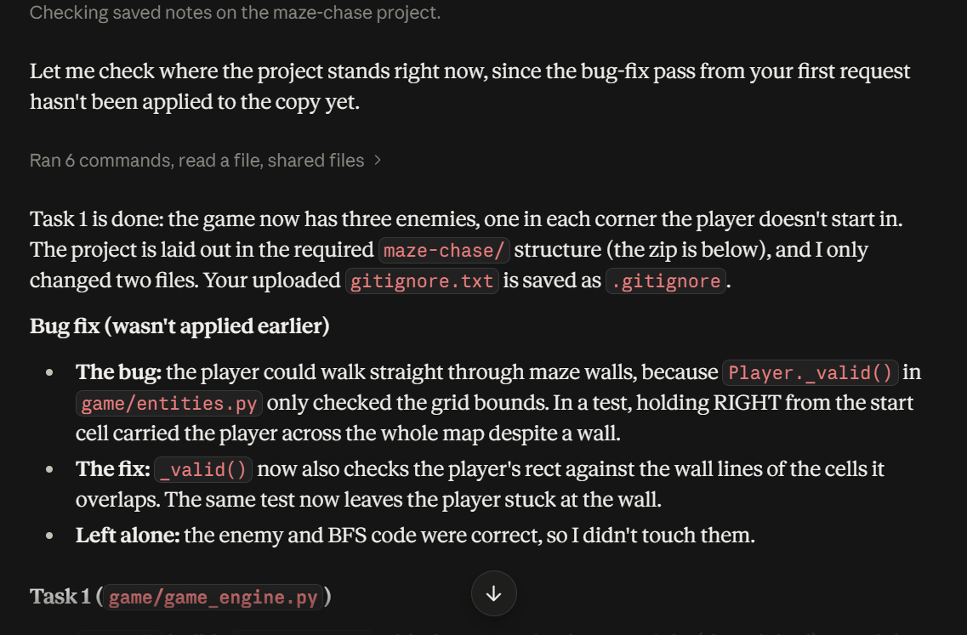
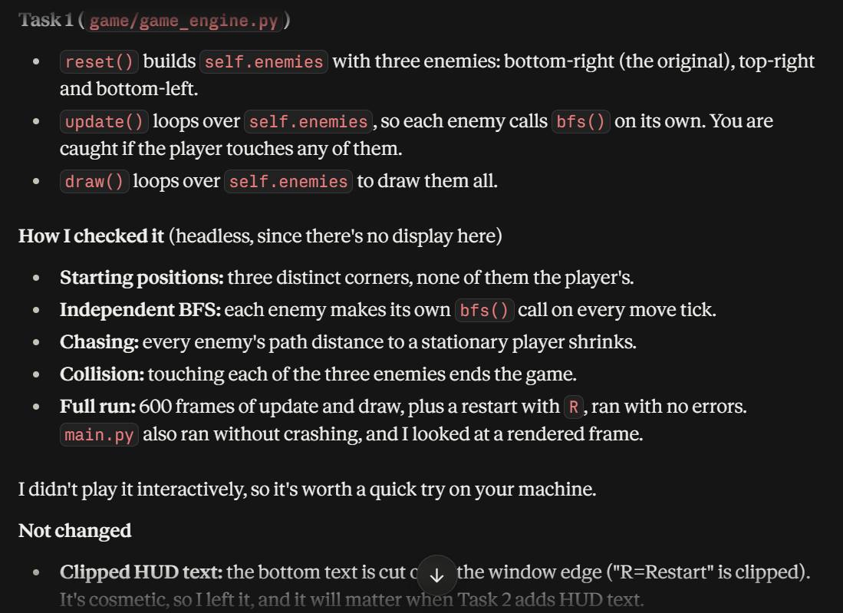
3.
Implement Tasks 2 and 3 from the README.
Task 2 — Speed Up Over Time:
- Track elapsed time using pygame.time.get_ticks().
- Every 15 seconds, decrease enemy.move_interval by 2.
- Minimum move_interval is 5.
- Apply the speed increase to all enemies.
- Show the current speed tier in the HUD.
Task 3 — Power Pellet:
- Add a visible yellow circular power pellet at a valid maze location.
- When the player collects it, freeze all enemies for 5 seconds.
- Use a 300-frame countdown.
- While frozen, enemies should not move or chase the player.
- Show a clear frozen indicator on frozen enemies.
Preserve Task 1 and all existing functionality. Test both features and fix any errors. Do not implement Task 4 yet.
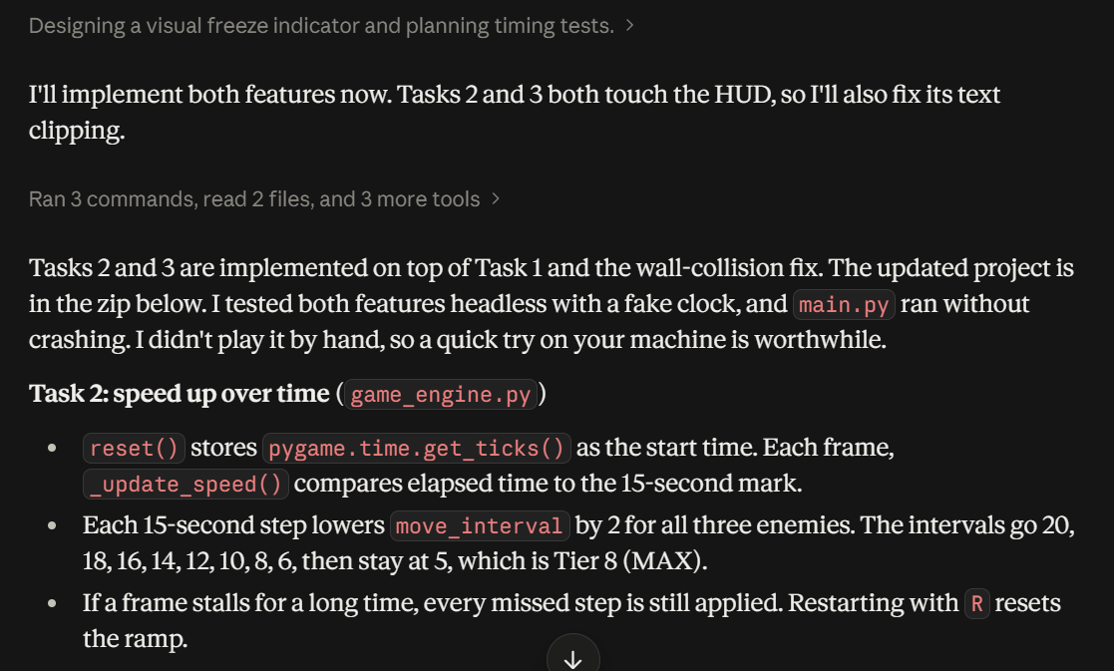
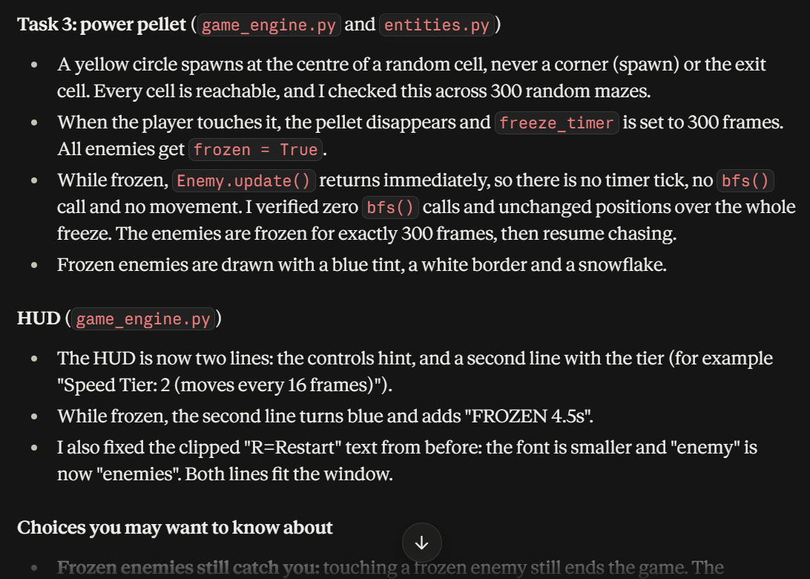
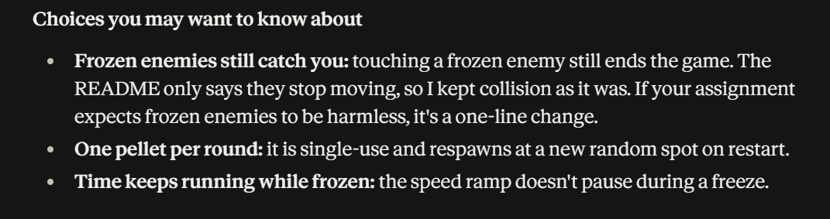

4.
Implement Task 4 from the README: Score by Distance.
Requirements:
- Add a self.score variable.
- Increment the score by 1 every frame while the player is alive.
- Display the score in the HUD as "Survived: Xs", where X = score // 60.
- Display the final survival score on the game-over overlay.
- Reset the score correctly when the game is restarted.
- Preserve Tasks 1, 2, and 3 and all existing functionality.
Test the complete game and fix any errors.

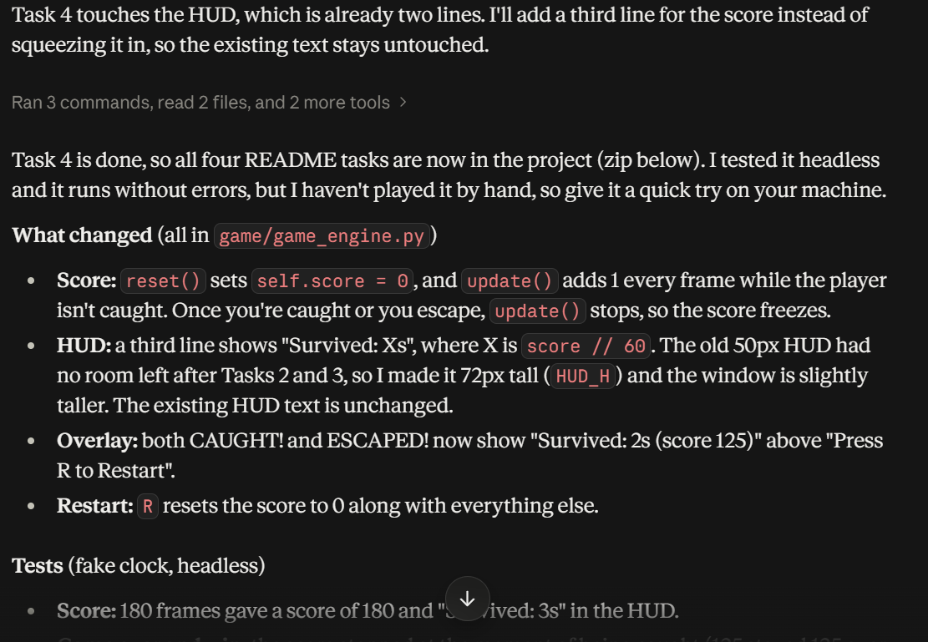
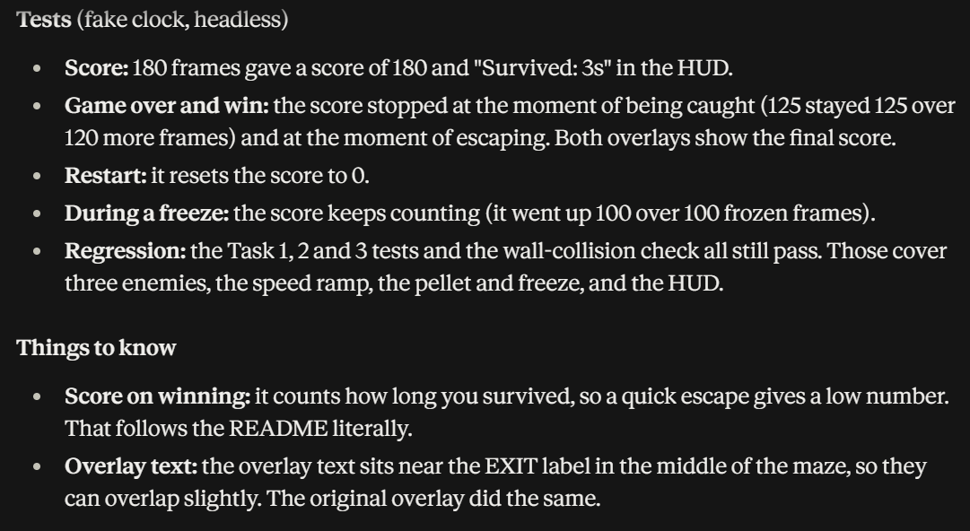

The code files with all the completed tasks have been uploaded in the repository.

Thank you

